|  |
| --- |
| Photo displaying partial image of two pie charts on a canvas-textured page |
| Play Simple Games  Data Analytics Assignment |
| |  |  |  | | --- | --- | --- | | KARTHIKEYAN R | 8/5/19 | Assignment | |

Contents

Executive Summary 2

Introduction 2

Content Analysis 2

Economy Factor Analysis 3

Findings and results of economy factor analysis 3

Assumptions 4

Engagement Factor Analysis 5

Findings and Results of engagement factor analysis 5

Assumptions 6

*Ranking Variants in the order of difficulty* 6

Findings and results of order of difficulty analysis 7

Retention Factor Analysis 8

Findings and Results of retention factor analysis 9

Assumptions 9

Final insights on content analysis experiment 9

Fast Follow Analysis 9

Candy Crush vs. Words with Friends 9

Analysis of key performance metrics 10

Final insights on Fast Follow Analysis 13

Recommendations 14

Attachments 14

References 15

Appendices 15

# Executive Summary

This report talks about the experiment run by play simple games company on three variant groups to test the content of one of their games by finding an optimal balance between revenue, engagement and retention metrics and also provides guidance to their senior management regarding better investment in fast following one of these two games: Candy crush saga and Words with friends. This report is designed to guide the senior executives in PlaySimple Games in making better business decisions.

The key findings of this study are:

1. The variant group 3 is the winner out of the three.

2. The rank of the variants in the order of their difficulty is 2, 1, and 3.

3. It is worth to invest in fast following Candy crush saga than Words with friends.

# Introduction

Casual games are a type of video games which do not require a significant time investment to play, win, and enjoy. A casual gamer is a person who plays the games spontaneously, infrequently, and irregularly. These games are often web-based and commonly played on mobile devices and personal computers. Microsoft solitaire is considered to be a first highly successful casual game when it got introduced in the year 1990. (Computer hope, 2019) and now the industry leaders in the casual gaming are Supercell is popularly known for developing ‘Clash of Clans’ and ‘Hay Day,’ Niantic is popularly known for developing Pokémon go and Tencent is famous for their ‘Honour of Kings’ game. (technavio blog, 2019)

Mobile gaming is unstoppable: According to App Annie, mobile games accounted for 74% of all consumer spending in app stores in 2018 alone, making it the fastest-growing sector in the overall gaming market. Mobile gaming eclipses both the PC and console games market, pulling in $70.3 billion in 2018, which accounted for 51% of the global games market according to Newzoo. App Annie predicts mobile gaming will continue to grow and reach 60% market share of consumer game spending by the end of 2019. (Lewis Leong, 2019)

With the rapid growing mobile gaming market, it is vital to consider improving several performance metrics for boosting the game’s earnings and revenue potential. Those metrics are as follows: DAU, MAU, ARPDAU, Retention rate, Players progress, etc…. (Jacqueline Zenn, 2018) Some of these metrics are used for the analysis performed for this assignment and their brief definition can be found in the appendices section.

PART -1

# Content Analysis

As stated in the assignment problem statement, there was an experiment conducted on three variant groups to analyse the content on one of the games developed by PlaySimple Games, to find the best fit group with optimum value in Economy factor, Engagement factor and Retention factor.

What follows is the analysis of several performance metrics involved in all these factors among the three variant groups.

# Economy Factor Analysis

Economy factor analysis for three variant groups in terms of their average purchase per dau was performed, and the results are shown below.

Lab. Overall average purchase per dau by three variant groups

## Findings and results of economy factor analysis

From the above chart, it is evident that variant group 2 has the highest overall purchase of value ₹10.74 slightly higher than the next in the group, variant group 3 with ₹10.64 and lastly variant group 1 with ₹9.82. Also, in terms of type, Spend and Earn, variant group 2 is the leader of this group with the values -₹72.11 and ₹54.67.

However, for a better understanding of how these variant groups behaved over the given period of the experiment, Weekly analysis of the purchase per dau made by the variant groups have performed, and the results are presented below:

Lab. Weekly average purchase per dau by three variant groups

The graph shows a decreasing trend in average purchase over the weeks. Based on the above chart, Variant group 3 have started the first week well with the average purchase value of ₹12.14 followed by variant group 1 with ₹11.55 and lastly variant group 2 with ₹10.90. After the second and third week, Variant group 2 tops the chart with an average of ₹10.66 followed by variant group 3 with ₹9.89 and lastly variant group 1 with ₹8.95.

So based on the above analysis, though variant group 3 started the first week well, it failed to perform better in the subsequent weeks likewise variant group 1 unlike variant group 2 started at a slower pace and maintained a steady average purchase dau over the course of the next two weeks thereby keeping a higher overall purchase per dau for the given period of the experiment.

Based on the overall average purchase per dau and average weekly purchase per dau comparisons analyses, it is ok to call variant group 2 as the leader in the economy metric analysis. Followed by variant group 3 in the second and variant group 1 in the third place.

## Assumptions

* The variable cash_per_dau is considered for the analysis instead of cash_per_user as users are the subset of dau.
* The variables like gid, version, experiment, and cli are considered as redundant data and have not used for analysis.
* The Spend and Earn type analysis was performed but not shown here because the purchase is considered as the primary source of revenue. However, these analyses are presented and available for viewing in the excel sheet in the attachments section.

# Engagement Factor Analysis

Engagement factor analysis for three variant groups in terms of their overall average dau was performed, and the results are shown below.

Lab: Overall average dau for three variant groups

## Findings and Results of engagement factor analysis

From the above chart, it is evident that variant group 3 has the highest overall dau of 7739, followed by variant group 2 with a value of 5993 and finally variant group 1 with 5643. Though overall average dau metric for variant 3 is the highest before terming it as a leader in the group, it is essential to have a clear picture of how average dau varied over weeks in the experiment.

Lab: Weekly average dau for the three variant groups

An increasing trend in average dau in seen from the above chart for all the three variant groups for the experiment period. From the above chart, it is evident that variant group 3 has the upper hand in starting week average dau than the other variants with a value of 7035 and goes onto to the value of 8092 in the subsequent weeks.

Based on the overall average dau and weekly average dau analyses, it is conclusive to call variant group 3 is the leader in the engagement metric analysis. Followed by variant group 2 in the second and variant group 1 in the third place.

## Assumptions

* The variable dau is considered for the analysis instead of users as users are the subset of dau.
* The variables like gid, version, experiment, and cli are considered as redundant data and have not used for analysis.
* These analyses are presented and available for viewing in the excel sheet attached in the attachments section.

# Ranking Variants in the order of difficulty

The three variant groups are ranked in their order of difficulty by performing average fail per dau analysis on the three variant groups, and the results are presented below:

Lab. Overall average fails by the three variant groups

## Findings and results of the order of difficulty analysis

Overall average fails per dau has been calculated for the three variant groups and sorted in the order of difficulty (i.e., one with maximum average fail per dau). The analysis can be seen from the above chart.

Based on the above chart it is evident that the variant group 2 has the maximum average fail per dau of value 7.01 and secures the first rank in the order followed by variant group 1 with the value of 6.92 takes the second rank and finally variant group 3 with the least average fail per dau value of 6.46 holds the last rank in the order of the difficulty which correlates with the fact that it has higher average dau.

|  |  |
| --- | --- |
| Rank in the order of difficulty | Variant group |
| 1 | 2 |
| 2 | 1 |
| 3 | 3 |

# Retention Factor Analysis

At first, the overall average installs for the given period of the experiment by three variant groups have been calculated, and presented below for analysis:

Lab. Overall average installs by the three variant groups

Also, Retention analysis is performed for the three variant groups by using their retention rates over the given period, as shown below:

Lab. Periodic retention rate comparison for three variant groups

## Findings and Results of retention factor analysis

Based on the average install analysis, variant group 3 tops the chart with 642 average installs followed by variant group 1 with a value of 489 and lastly variant group 2 with a value of 487. Based on the average retention rate analysis, variant group 2 takes over the first place by a slight margin from variant group 3 and variant group 1 finishes last in the group. 30-day retention rate is 0 for all the variant groups which strictly needed attention and immediate response.

## Assumptions

* The variables like gid, version, experiment, and cli are considered as redundant data and have not used for analysis.
* Only D1, D3, D7, D14 & D21 are considered for analysis as they are in regular intervals. These analyses are presented and available for viewing in the excel sheet attached in the attachments section.

# Final insights on content analysis experiment

Though variant group 2 leads variant group 3 in economy and retention analysis, it fails big time against variant group 3 in the average number of installs and the average dau and even in economy and retention analysis, variant group 3 performed on par with the variant group 2 as the difference is only on a slighter margin.

With a higher average dau for the given period, higher average number of installs, performing on par with variant group 2 in retention and economy, we can finally name variant group 3 as a winner among the three variant groups.

Variant group 3 is the winner

↑ The average number of installs compared to other variant groups

↑ The average DAU for the given period compared to other variant groups

↔ The retention rate with variant group 2 & ↑ The retention rate than variant 1

↔ The average revenue per DAU with variant group 2 & ↑ The average revenue per DAU than variant 1

↓ The average fails per DAU compared to other variant groups

PART-2

# Fast Follow Analysis

# Candy Crush vs. Words with Friends

Candy Crush Saga is a legendary puzzle game developed by King in the year 2012, and it is one of the most popular mobile games of all time. Words with Friends is the fun, free word game that lets you connect with friends and family while expanding your vocabulary and sharpening your wit and it is developed by Zynga Inc. in the year 2009. (Sensortower,2019)

What follows now is the analysis of several key performance metrics of these two games to determine which one out of these two games are worth Fast Following. The retention data is provided within the assignment problem statement, and other metric data’s that are used for analysis are taken from the sources like Sensortower, Videogamestats, and Statista. These website URL’s are mentioned in the references section. The whole analysis with an interactive dashboard is presented in an excel sheet attached to this document for your reference.

## Analysis of key performance metrics

Lab. Retention rate for day 1, day 30, and their drop-in percentage for one month is compared

Based on the retention analysis, it is evident that Words with Friends have high retention rate at day1, day30, and also low drop in retention percentage for one month with a value of 58%. Candy Crush starts with a retention rate of 55 at day1 and falls to 15 at day 30 with a drop-in retention percentage of 73%. Retention rate is not the only metric used for performance analysis, so it is necessary to continue the study by considering other vital metrics.

Lab. Revenue in millions USD for Candy Crush and Words with Friends

Based on the above chart, it is clear that Candy Crush saga aced the revenue metric with a value of 24 million USD where Words with Friends just have revenue of 0.2 million USD. Considering the revenue metric, it is evident that the revenue of the Candy Crush saga is 120 times the revenue of the Words with Friends.

Lab. Downloads in millions for Candy Crush and Words with Friends

Based on the above chart, it is clear that Candy Crush saga tops the chart in download metric too with a value of 8 million where Words with Friends have a value of 0.08 million. Considering downloads metric, it is evident that downloads of Candy Crush saga are 100 times the downloads of Words with Friends.

Lab. DAU in millions for Candy Crush and Words with Friends

DAU is one of the crucial metrics to be considered before fast following. This metric shows the engagement factor and also gives us an idea about the daily revenue estimate. Based on the above chart, it is clear that the DAU of Candy Crush is ten times the DAU of Words with Friends, which makes our decision to fast follow much easier.

Lab. MAU in millions for Candy Crush and Words with Friends

Though DAU gives us a clear picture of how many users are actively playing the game on a given day, it is also critical to consider MAU for long-term analysis. Based on the above chart, MAU of Candy Crush is approximately 21 times the MAU of Words with Friends by which we can decide that Candy Crush is more engageable, profitable and popular than Words with Friends.

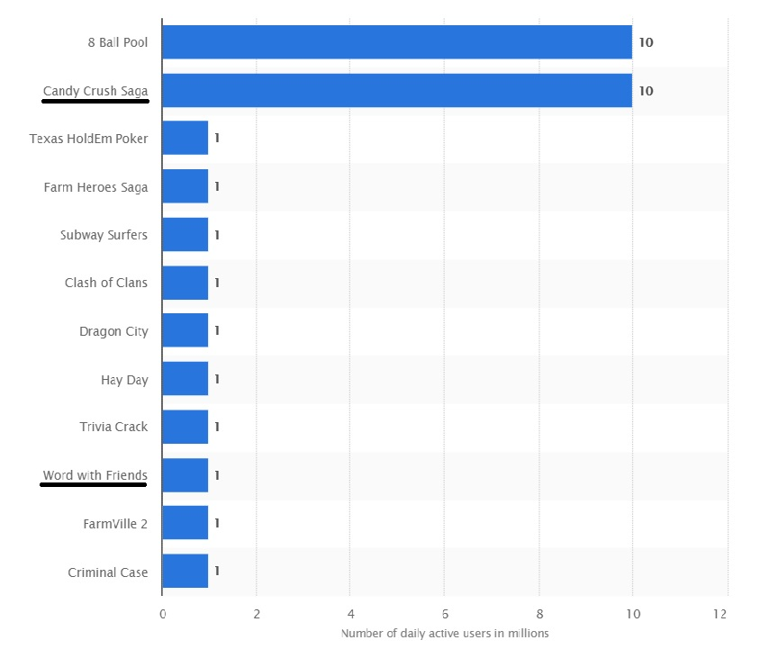

Lab. Popularity of different games on Facebook in terms of DAU in millions (Christiana Gough, 2019).

# Final insights on Fast Follow Analysis

Although Words with Friends lead Candy Crush on the retention metric, it loses big time to Candy Crush in terms of Revenue, Downloads, DAU and MAU.

With higher revenue, higher downloads, higher DAU, higher MAU, higher positive reviews (sensortower.com, 2019) and higher popularity in Facebook (Christiana Gough, 2019). It is crystal clear that fast following Candy Crush is a better investment.

CANDY CRUSH SAGA IS BEST SUITED FOR FAST FOLLOWING

↑ Revenue compared to Words with Friends

↑ Downloads compared to Words with Friends

↑ DAU compared to Words with Friends

↑ MAU compared to Words with Friends

↑ Popularity & ↑ Positive reviews to date

# Recommendations

* Regarding the content evaluating experiment conduced on three variant groups over 24 days, several performance metric analyses were performed and based on the higher install, higher DAU and par retention rate and average revenue per dau with group 2, It is evident that Variant 3 is the winner among the three variant groups.
* Regarding Order of Difficulty analysis, variant group 2 ranked first with the higher average number of fails followed by variant group 1 in the second place, and finally, variant group 3 ranked third in the order of difficulty with the comparatively less average number of fails.
* Regarding Fast Follow Analysis, with higher revenue, higher downloads, higher DAU, higher MAU, higher popularity and higher positive reviews, Candy Crush Saga is the clear winner against the Words with Friends and I, therefore, recommend PlaySimple Games gaming studio to fast follow Candy Crush Saga as it is a better investment on overall performance measures.

# Attachments

All the analysis performed for this assignment can be found in these excel workbooks. A dashboard is also included in the Fast Follow Analysis Workbook

 

 

# References

1.Computer hope (2018) [online]. Casual gaming. [<https://www.computerhope.com/jargon/c/casual-gaming.htm>]. Accessed August 02, 2019.

2.Gough, Christiana (2019) [online]. Most popular Facebook games. [<https://www.statista.com/statistics/267003/most-popular-social-games-on-facebook-based-on-daily-active-users/>]. Accessed August 02, 2019.

3.Leong, Lewis (2019) [online]. The 5 biggest mobile gaming trends. [<https://blog.applovin.com/5-biggest-mobile-gaming-trends-2019-app-annie-report/>]. Accessed July 30, 2019.

4.Smith, Craig (2019) [online]. Words with Friends stats and facts. [<https://videogamesstats.com/words-with-friends-stats-facts/>]. Accessed July 30, 2019.

5.Smith, Craig (2019) [online]. Candy Crush stats and facts. [<https://videogamesstats.com/candy-crush-facts-statistics/>]. Accessed July 30, 2019.

6.Sensor tower (2019) [online]. Candy Crush Saga statistics. [<https://sensortower.com/android/US/king/app/candy-crush-saga/com.king.candycrushsaga/overview>]. Accessed July 31, 2019

7.Sensor tower (2019) [online]. Words with Friends statistics. [<https://sensortower.com/ios/US/zynga-inc/app/words-with-friends-word-game/804379658/overview>]. Accessed July 31, 2019

8.Technavio blog (2019) [online]. Top 30 mobile gaming companies in the world. [<https://blog.technavio.com/blog/top-31-mobile-gaming-companies>]. Accessed August 02, 2019.

9.Zenn, Jacqueline (2018) [online]. 9 metrics for maximizing revenue. [<https://gameanalytics.com/blog/9-metrics-maximum-revenue.html>]. Accessed August 02, 2019.

# Appendices

1. DAU/dau – Daily Active Users
2. MAU/mau – Monthly Active Users
3. Retention rate – Percentage of people playing the game on a given day out of the players installed the game on that day. This metric is used to evaluate the stickiness factor.
4. Cli – Client – 0 represents it is Android.
5. Version – 2.0
6. Experiment – Content
7. Users – Players performing a specific activity.
8. Experiment start date – 24/08/2015, Experiment end date – 16/09/2015
9. For the PART-2, Fast Follow Analysis, Data used for analysis are taken from references 4, 5, 6, and 7 from the references section.